## Problem 2 – SoftWars

You are given an unresponsive Web site (**HTML** + **CSS** + images). Your task is to **make the site responsive**. The site layout should change according to the browser viewport / screen size. You need to implement 2 layouts: **width < 480px and width < 1024px**. The figures below represents this layout:



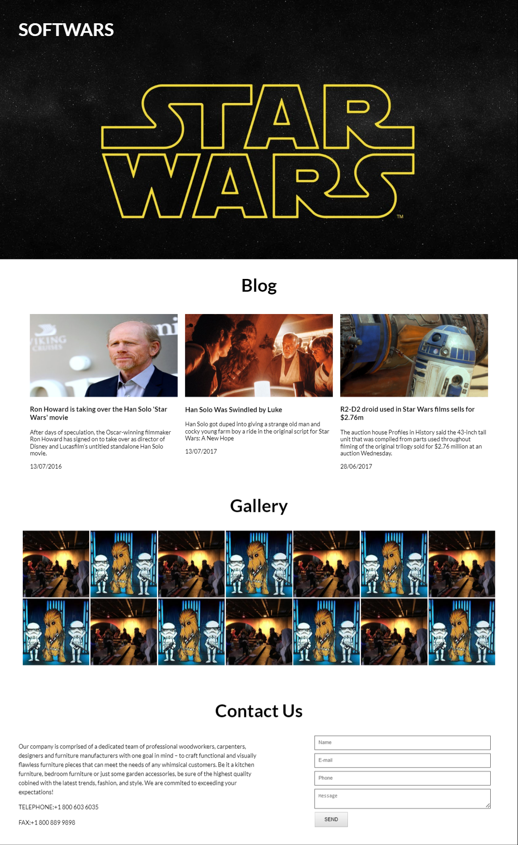

### Input

You are given the unresponsive site as HTML + CSS + images.

### Output

The output should be valid HTML5 + CSS3 + images that implement the above responsive site.

### Constraints

* You are free to change the HTML and CSS, as well as use external frameworks like Bootstrap.
* Pixel-perfect implementation is not required.